Sally’s Baking Addiction: In-Depth Competitive Analysis

App
Sally’s Baking Addiction

Best known for
Desserts and baking confidence for home bakers

Core angle
Step-by-step baking confidence

Key Features
• 1,200+ tested recipes, step-by-step tutorials, and expert baking tips • Covers cookies, cakes, pies, breads, candy, muffins, and beginner baking recipes • Strong tutorial and troubleshooting orientation for scratch baking

What works:
- Ultimate Recipe Reliability: As a home baker, my biggest fear is wasting expensive ingredients (like high-quality butter and pure vanilla extract) on a recipe that fails. Sally’s recipes are incredibly reliable. When I follow her instructions, the bake turns out exactly as promised, which builds immense confidence in the kitchen.
- The Science Behind the Bake: I love that she doesn’t just list ingredients and instructions. She explains why we use specific techniques—like why we need room-temperature eggs, why cornstarch makes cookies soft, or how creaming butter and sugar creates structure. This "Baking 101" education helps me become a better baker overall.
- Step-by-Step Visual Walkthroughs: The blog posts are filled with clear, high-quality photos showing exactly what the batter, dough, or meringue should look like at every single stage. Seeing what "stiff peaks" or "soft, creamed butter" actually looks like on screen is an absolute lifesaver.
- Precise Weight Measurements (Metric Toggle): For baking, accuracy is everything. Having an easy button to switch the recipe card from standard US cups to metric grams is amazing. Using a kitchen scale is so much cleaner and more accurate, and she fully supports this.
- Active and Supportive Community QA: If I’m unsure about a substitution or run into an issue, the comments section is a goldmine. Sally and her team actually respond to questions, helping troubleshoot in real-time. It feels like having a professional baker standing in the kitchen with me.

What doesn’t work:
- Frustrating Ad-Heavy Interface: The sheer volume of display ads is overwhelming, especially on mobile. Ads constantly pop up, reload, and shift the page content up and down (Cumulative Layout Shift) while I am reading. It is incredibly frustrating when my hands are covered in flour and the step I was reading suddenly jumps off the screen.
- Endless Scrolling to Reach the Recipe: While the educational tips and step-by-step photos are helpful for the first bake, scrolling through 2,000 words of blog post to finally reach the actual recipe card at the bottom of the page is tedious when I just want to quickly double-check a measurement.
- Messy and Cluttered Comment Navigation: With popular recipes having thousands of comments, trying to find a specific tip (like a gluten-free substitution) is almost impossible. There is no way to search within the comments or filter by top-rated tips, so I have to scroll through page after page of text.
- Lack of a Native Dark Mode: Baking early in the morning or late at night in a dimly lit kitchen with a blinding white screen is painful. I really wish there was a simple dark mode toggle built directly into the site to make it easier on the eyes.
- Basic Search Limitations: The search bar in the header is quite basic. If I search for "chocolate chips," it returns a massive, unorganized list of everything from cookies to blog updates. I can't easily search for recipes based on "what's in my pantry" (like having leftover buttermilk and sour cream).

Recipe library patterns:
The Recipe Index serves as a visual hub for browsing Sally’s massive catalog of over 1,200 recipes.
- Multi-Select Filter Dropdowns: The index features five straightforward, user-friendly dropdown filters: Type, Dietary, Occasion, Season, and Skill Level. This makes it incredibly easy to filter down to something highly specific, like a "Beginner," "Gluten-Free" "Cookie" for "Christmas."
- High-Quality Visual Grid: Once filtered, recipes appear in a beautiful responsive grid of cards. Each card displays a stunning, mouth-watering photo of the finished bake, the title, and sometimes star ratings or quick difficulty badges.
- Dynamic and Fast Updating: The page updates instantly as filters are applied, allowing me to explore different categories without waiting for slow pages to reload.
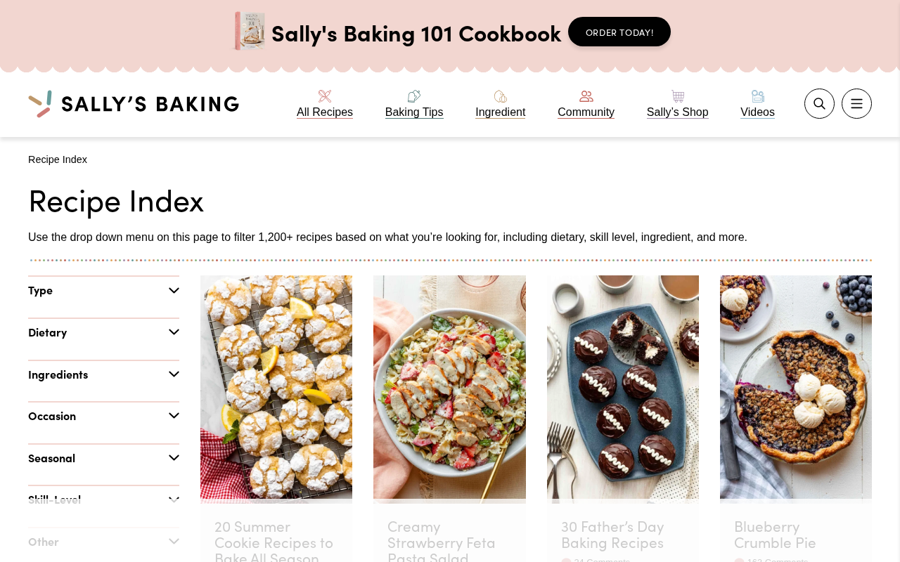

Recipe detail patterns:
The recipe detail page is where the actual cooking happens, housing the printable recipe card at the bottom of the long blog post.
- "Jump to Recipe" Shortcut: A big, high-contrast button is placed right at the top of the page. If I've made the recipe before or just want to start baking immediately, I can click it to skip all the text and go straight to the recipe card.
- Interactive Metric/US Customary Toggle: Inside the recipe card, there is a prominent toggle for "US Customary" and "Metric." Clicking "Metric" instantly swaps cups and spoons to grams and milliliters, which is essential for accurate weighing.
- Dynamic Serving Scaling: The ingredient list has interactive buttons to scale the recipe (e.g., 1x, 2x, 3x). If I want to double a cookie batch, clicking "2x" automatically doubles all the ingredient quantities in the list, saving me from doing mental math and making mistakes.
- Ink-Saving Print Button: A dedicated "Print" button opens a beautifully formatted, ad-free page that strips out all the blog photos and background clutter, giving me a clean paper copy to keep on my kitchen counter.
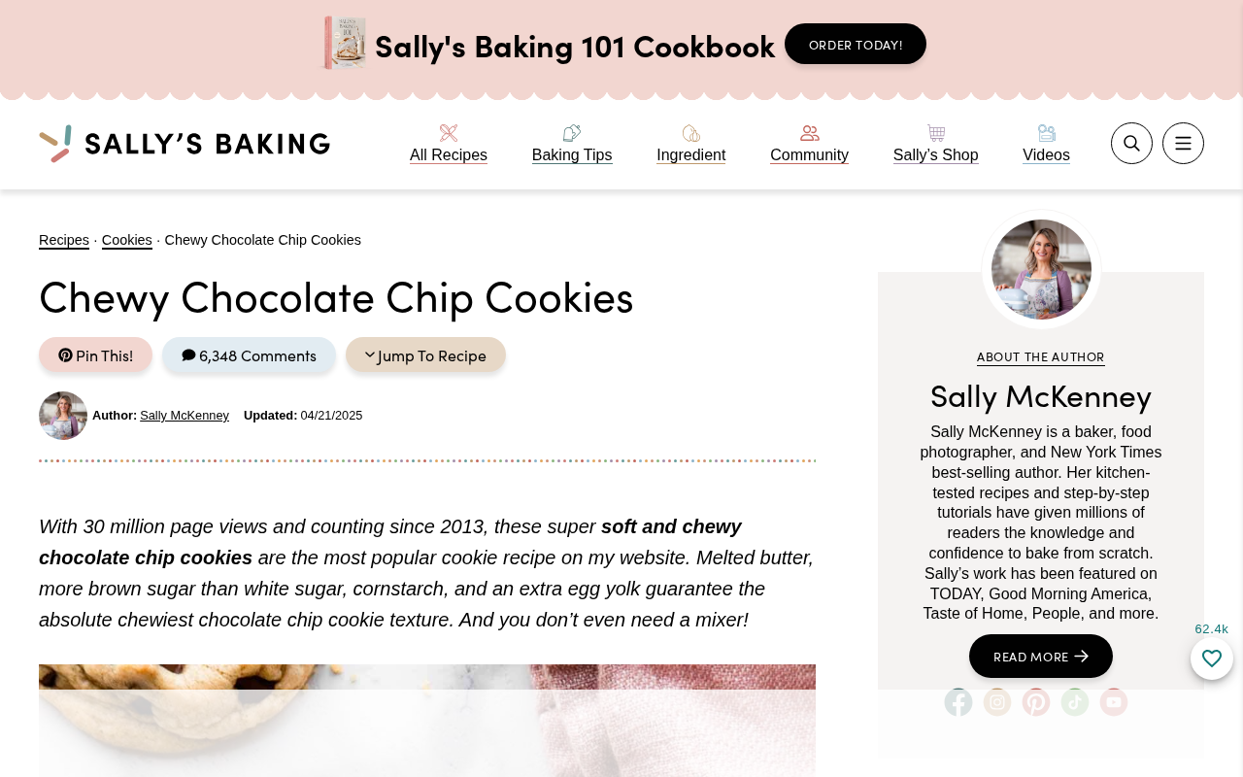

Search/filter patterns:
The website offers quick search tools to locate recipes across the platform.
- Sticky Global Search Bar: Located in the top navigation header on both desktop and mobile, a clean search magnifying glass icon expands into an input field, making it accessible no matter where I am on the site.
- Visual Category Bubbles: The search and index pages feature large, rounded, illustrative icons for popular categories (e.g., Cookies, Cakes, Breads, Pies) acting as visual shortcuts for quick, tap-and-go browsing.
- Live Suggestions: Typing in the search field provides instant, visual dropdown suggestions with recipe thumbnails, helping me find the exact recipe without completing the query.


Guided cooking patterns:
Sally’s Baking Addiction excels at guiding home bakers through complex techniques.
- Embedded Step-by-Step Video Tutorials: For technically challenging bakes (like laminating croissant dough or braiding challah), a high-quality video tutorial is embedded directly in the post, showing hands-on hand movements and technique demonstrations.
- Hands-Free "Cook Mode" Toggle: Inside the recipe card, a "Cook Mode" toggle prevents the phone or tablet screen from sleeping. This is an absolute game-changer, as I don't have to wash my hands to wake up my phone every time I need to read the next step.
- Chronological Visual Milestones: Throughout the blog post body, bold headers and descriptive photos act as visual milestones (e.g., "Step 1: Cream the butter and sugar until fluffy", followed by an image of the perfect fluffy texture).
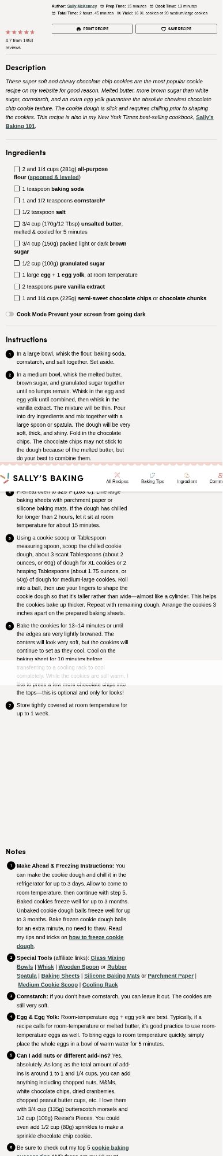

Save/share patterns:
Since the site does not have a dedicated mobile app, it relies on third-party integrations and social platforms to help users save and share their favorite bakes.
- Grow.me Integration: Clicking "Save Recipe" inside the recipe card connects to the Grow.me publisher widget. This saves the bookmark to a unified account, allowing me to organize my favorite recipes from Sally's and other food blogs in one personal dashboard.
- Instant Pinterest Pinning: Hovering over any image on the site overlays a "Pin" button, making it seamless to add the recipe to my personal holiday baking or dessert boards.
- Standard Social Share Tray: Clear, modern sharing buttons for Facebook, Twitter, and Email are located at both the top and bottom of each post for easy sharing with friends and family.


Additional features worth noting:
- Sally’s Baking Challenge: A highly engaging monthly community event. Sally posts a specific baking challenge on the 1st of each month (e.g., French Macarons or Homemade Croissants), and readers submit a photo of their bake to be entered into a giveaway. It is incredibly motivating and makes baking feel social.
- Baking 101 Reference Library: A dedicated section of the website focused entirely on foundational skills, detailed ingredient guides, and kitchen math conversions (e.g., how to measure flour correctly, yeast troubleshooting).
- Built-in Success & Substitution Tips: At the bottom of almost every recipe card, there is a dedicated notes section containing bulletproof tips for making the recipe gluten-free, dairy-free, egg-free, or freezing instructions.
